SCT1-86E
DC speed and torque regulating closed-loop driver

User Manual V1.0.3

Shenzhen GRMOT Technology Co., Ltd.

Table of contents
1. Product Introduction 1
1.1 Product Overview 1
1.2 Product Features 1
1.3 Application Areas 1
1.4 Naming Rules 2
2. Electrical, mechanical and environmental indicators 3
2.1 Mechanical Installation Drawings 3
2.2 Enhanced heat dissipation methods 3
2.3 Electrical Specifications 3
2.4 Usage Environment and Parameters 4
3. Driver Interface and Wiring Introduction 4
3.1 Interface Diagram 4
3.2 Interface Description 5
3.2.1 Encoder Interface 5
3.2.2 Motor control output interface 5
3.2.3 Power Input Interface 5
3.2.4 Programming and Debugging Interface 5
3.3 Wiring Requirements 6
4. Function Description 6
4.1 Panel Function Diagram 6
4.2 Digital Tube Display 7
4.3 Torque and speed adjustment 8
4.4 Start-stop control 8
4.4.1 Panel switch controls start and stop 8
4.5 Special Functions 8
4.5.1 Adjustment of maximum output torque value 8
4.5.2 Maximum Output Speed ​​Adjustment 9
4.5.3 Other functional adjustments 9
5. Power supply selection 10
6. Indicator lights and alarm indicators 11
7. Warranty and after-sales service 12
7.1 Warranty 12
7.1.1 Free Warranty Status 12
7.1.2 Cases not covered by warranty 12
7.2 Exchange 12
7.2.1 Product replacement due to malfunction 12
7.2.2 Replacement for non-product malfunctions 13
7.3 Returns 13
7.4 After-sales service 14
8. Version Revision History 14

Product Introduction

1.1 Product Overview
The SCT1-86E driver is a newly launched DC speed- and torque-adjustable closed-loop stepper driver from Greenlink IoT Technology Co., Ltd., featuring a 4-digit LED display.Users can adjust the speed and torque levels using a knob, and the digital display can...Displays the set speed and torque level values; driver power supply voltage range.DC24V~70V, mainly matched with 86-base closed-loop motors, but can also drive 42~60-base closed-loop motors..

1.2 Product Features
● Compact design for easy installation
● New generation 32-bit DSP technology, offering excellent stability, strong compatibility, and high cost-effectiveness.
● Compatible with closed-loop motors with base plates ranging from 42 to 86mm.Mainly matched with closed-loop motors based on 86 base.
● Equipped with a 4-digit digital display showing speed and torque rating.
● The speed and torque levels can be adjusted via the knob.
● The forward, reverse, and stop functions can be controlled via a 3-position, 3-pin switch.
●Low vibration and low noise
●Features overvoltage and undervoltage alarm protection functions
●Input voltage range:DC24V~70V

1.3 Application Areas
Suitable for various small and medium-sized automated equipment and instruments, such as: intelligent logistics, textile industry, barrier gate industry, winding industry, etc.

1.4 Naming Rules
The naming conventions for driver models are as follows:
SCT1-86E--
① ② ③ ④ ⑤ ⑥

Serial Number | meaning
① | Product series name; SCT: Speed ​​control type products;
② | Product series number; 1: Series number is 1;
③ | Matching motor base; 86: Primarily matches motors with 86 bases;
④ | Open-loop/closed-loop drive; E: closed-loop;
⑤ | Special function codes;
⑥ | Design change code;

Electrical, mechanical and environmental indicators

2.1 Mechanical Installation Drawings
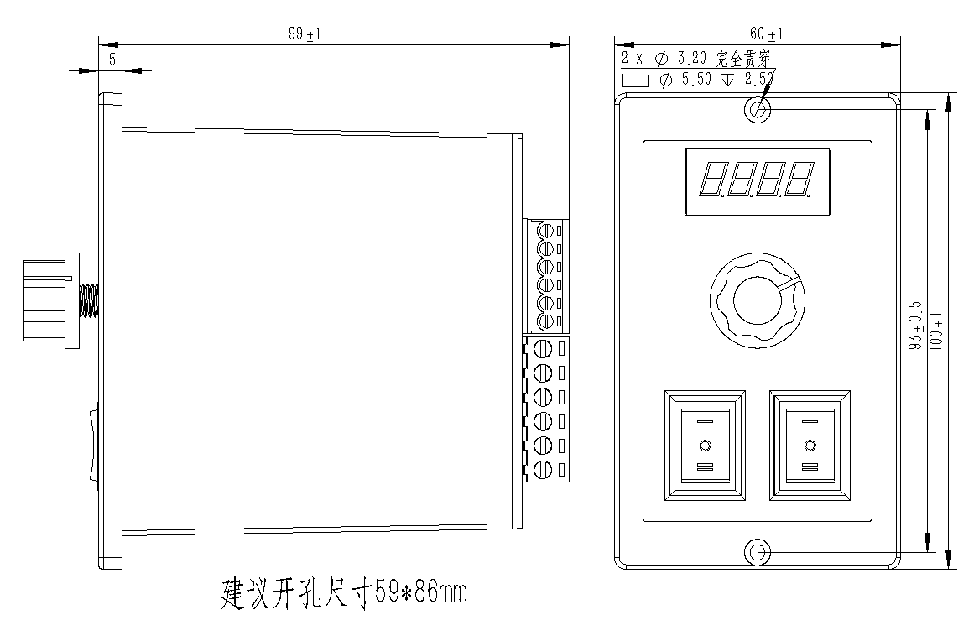
Figure 2.1 Installation dimensions (unit: mm)
Side mounting is recommended for better heat dissipation. When designing the installation dimensions, the size of the wiring terminals and the wiring should be considered.

2.2 Enhanced heat dissipation methods
- The reliable operating temperature of the drive is usually below 50℃, and the operating temperature of the motor is below 80℃.
- When installing the driver, strong air convection can be formed on the side of the driver; if necessary, a fan can be installed inside the machine near the driver to form air convection, assist in cooling the driver, and ensure that the driver operates within a reliable operating temperature range.

2.3 Electrical Specifications
illustrate | SCT1-86E
illustrate | Minimum value | Typical value | Maximum value | unit
Input DC power supply voltage | twenty four | 48 | 70 | VDC
Insulation resistance | 50 |  |  | MΩ

2.4 Usage Environment and Parameters
Cooling method |  | Natural cooling, fan cooling
Usage Environment | occasion | Do not place near other heat-generating equipment. Avoid dust, oil mist, corrosive gases, high humidity, and areas with strong vibrations. Keep out of reach of flammable gases and conductive dust.
Usage Environment | temperature | 0-50℃
Usage Environment | humidity | 40-90%RH
Usage Environment | vibration | 10~55Hz/0.15mm
Storage temperature |  | -20℃~65℃

Driver Interface and Wiring Introduction

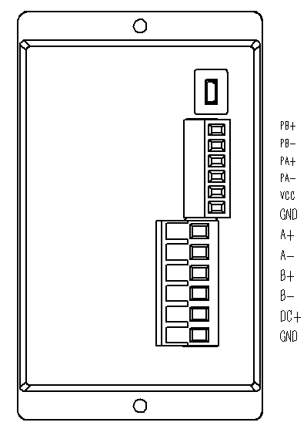
3.1 Interface Diagram

Figure 3.1 SCT1-86E Interface Diagram

3.2 Interface Description
The SCT1-86E DC speed- and torque-adjustable closed-loop driver uses 5.08-6P terminal blocks for the power supply and motor interfaces, 3.81-6P terminal blocks for the encoder interface, and a MINI USB interface for programming and debugging. See the following sections for detailed interface definitions.

3.2.1 Encoder Interface
name | Function
PB+ | For the encoder's B-phase input interface, pay attention to the wiring sequence.
PB-
PA+ | For the encoder's A-phase input interface, pay attention to the wiring sequence.
PA-
VCC | The encoder is powered by a 5V power supply.
GND | The encoder is powered by a 5V power supply at the negative terminal.

3.2.2 Motor control output interface
name |  | color | illustrate | Function
Motor | A+ | red | Motor interface | For two-phase stepper motor wiring terminals, pay attention to the wiring sequence.
Motor | A- | blue | Motor interface
Motor | B+ | green | Motor interface
Motor | B- | black | Motor interface

3.2.3 Power Input Interface
name |  | illustrate | Function
VDC | DC+ | Power interface | Supports DC power input  DC24V~70V
VDC | GND | Power interface | Supports DC power input  DC24V~70V

3.2.4 Programming and Debugging Interface
The SCT1-86E driver uses a MINI USB interface for serial communication. It can be connected to a PC via a USB-to-TTL serial converter using the dedicated debugging cable provided by our company. Hot-plugging is strictly prohibited! On the PC, customers can set the required parameters, such as maximum current and maximum speed. For details, please refer to the host computer software interface.
Terminal number | symbol | name | illustrate
1 | NC | - | For internal use
2 | NC | - | For internal use
3 | GND | Serial communication ground | 0V
4 | NC | - | For internal use
5 | NC | - | For internal use
6 | NC | - | For internal use
7 | RXD | Serial port receiver
8 | TXD | Serial port transmitter
▶Note: The debugging cable connecting the SCT1-86E to the PC is a dedicated cable (provided depending on the user's needs). Please confirm before use to avoid damage.

3.3 Wiring Requirements
- The motor wires and encoder wires must be shielded to prevent interference signals from entering the encoder signal terminal, affecting the operating performance, and causing system instability and other malfunctions.
- If a power supply powers multiple drivers, they should be connected in parallel at the power supply point. A chain-like connection, where the power supply goes to one driver first and then to the next, is not allowed.
- It is strictly forbidden to plug or unplug the high-voltage terminals of the driver while it is powered on. Even when the motor is stopped, a large current still flows through the coil. Plug or unplug the terminals while they are powered on, which will cause a huge instantaneous induced electromotive force and burn out the driver.
- It is strictly forbidden to tin the wire ends before connecting them to the terminals, otherwise the terminals may overheat and be damaged due to increased contact resistance.
- The wire ends must not be exposed outside the terminals to prevent accidental short circuits that could damage the driver.

Function Description

4.1 Panel Function Diagram
The functional diagram of the SCT1-86E DC speed-regulating and torque-regulating closed-loop driver panel is shown below.

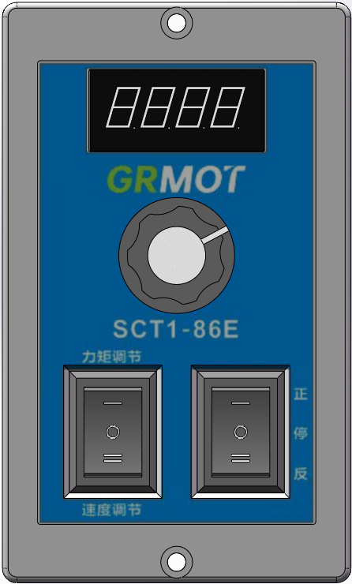

Figure 4.1 Schematic diagram of SCT1-86E panel functions

4.2 Digital Tube Display
The SCT1-86E DC speed-regulating and torque-regulating closed-loop driver uses a 4-digit digital tube to display the speed and torque level values.As shown in the following figure.
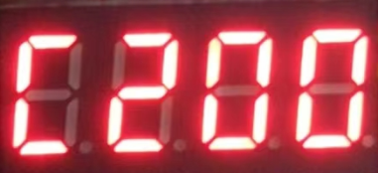 | The digital display shows 'C200', indicating that the current torque value is 200. At this time, the torque output value can be adjusted by the knob, with the default adjustment range being 0-200.
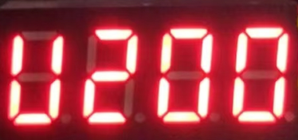 | The digital display shows 'U200', indicating that the current speed output value is 200 rev/min; at this time, the speed output can be adjusted by the knob, with the default adjustment range being 0-200 rev/min;
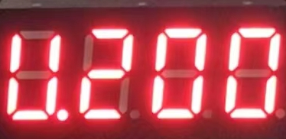 | The digital display shows 'U.200', indicating that the current speed is 200 rev/min, and rotating the knob is ineffective at this time and will not affect the set torque and speed values.
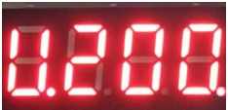 | When the panel direction control rocker switch is turned onThe decimal point of the fourth digit LED display lights up;

4.3 Torque and speed adjustment
The torque and speed settings are both 0-200. You can switch to the corresponding setting (torque mode or speed mode) using the 3-pin 3-speed switch, and then adjust it using the knob. The specific relationship is as follows:
Torque, speedAdjust the position of the switch | Knob adjustment value | describe
'I' | Adjusting the torque output value | Range: 0-200
'II' | Adjust the output speed value | Range: 0-200, Unit: rev/min
'O' | Knob adjustment function is ineffective | -

4.4 Start-stop control

4.4.1 Panel switch controls start and stop
The motor's forward, reverse, and stop functions can be controlled via the three-position switch on the front panel of the SCT1-86 driver. The control logic is shown in the table below:
Position of the forward/reverse adjustment switch | Motor motion status | describe
'I' | Forward | -
'II' | Reversal | -
'O' | stop | It will eventually be in a released state, allowing users to rotate it without resistance.

4.5 Special Functions

4.5.1 Adjustment of maximum output torque value
When the torque and speed adjustment switch is in the 'I' position, press and hold the knob for 3 seconds. The digital display will then switch to the display shown in the image below. At this time, you can adjust the maximum value of the driver's output current using the knob. The default setting is 4000 mA, and the adjustable range is 0-6000 mA with a resolution of 100. After setting the desired maximum current value, press the knob switch once. The set current (i.e., torque) maximum value will be automatically saved, and the current torque setting value Cxxx will be displayed.(xxx is the torque setting value).
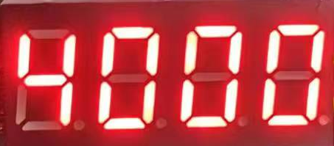

4.5.2 Maximum Output Speed ​​Adjustment
When the torque and speed adjustment switch is in the 'II' position, press and hold the knob for 3 seconds. The digital display will then switch to the display shown in the image below. At this time, you can adjust the maximum speed of the driver using the knob. The default setting is 200, unit: rev/min, adjustable range is 0-3000, resolution is 1. After setting the desired maximum speed value, press the knob switch once to automatically save the set maximum speed value and display the current speed value Uxxx.(xxx is the rotational speed value).
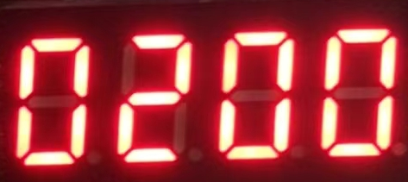

4.5.3 Other functional adjustments
When the torque and speed adjustment switches are in the 'O' position, press and hold the knob for 3 seconds, and the digital display will switch to the function display Pxxx (xxx is the function code) as shown in the figure below:
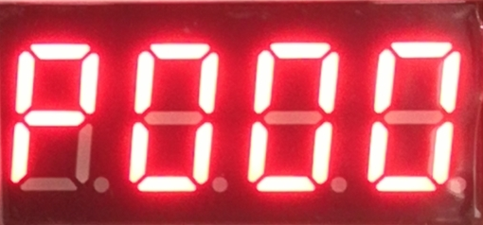
Function codes can be selected using the knob. After selecting the desired function code, press the knob switch to enter the corresponding parameter adjustment interface. Currently, the following options are available:ofFunction codeas well asThe specific descriptions are shown in the table below:
Function code | Function Description | Detailed description
P000 | Select the compatible motor series number | There are four selectable values: 86, 57, 42, and 60, corresponding to four different motor series. The default setting is 86. After selecting the corresponding motor series, press the knob switch to automatically save the selection. The digital display will then show the current speed value U.xxx.(xxx is the rotational speed value);
P001 | Select the lock-up current ratio after shutdown | The setting range is 0~100, with a default value of 0. After setting the lock current ratio, pressing the knob switch will automatically save the set lock current ratio value, which will then be displayed on the digital tube.The current speed value U.xxx is displayed correctly.(xxx is the rotational speed value);
P002 | invalid
P003 | Set acceleration time | Set range 0~5000, the default value is1000; when setaccelerateThen, press the knob switch once, and the settings will be saved automatically.Acceleration timeSubsequently, the digital tubeThe current speed value U.xxx is displayed correctly.(xxx is the rotational speed value);
P004 | Set deceleration time | Set range 0~5000, the default value is500; when setslow downThen, press the knob switch once, and the settings will be saved automatically.deceleration timeSubsequently, the digital tubeThe current speed value U.xxx is displayed correctly.(xxx is the rotational speed value);

Power supply selection
It can operate normally as long as the power supply voltage is within the specified range. (SCT1-86E)The driver is best powered by a regulated DC switching power supply, and the output current range of the switching power supply should be set to its maximum. An unregulated DC power supply can also be used, but care must be taken to ensure that the peak voltage ripple after rectification does not exceed its specified maximum voltage. It is recommended that users use a DC voltage lower than the maximum voltage to avoid mains fluctuations exceeding the driver's operating voltage range.
If a regulated switching power supply is used, the output current range of the switching power supply should be set to its maximum.
Notice:
- When wiring, be careful to ensure that the positive and negative terminals of the power supply are not reversed;
- When wiring, pay attention to the position of the power interface and do not connect it to the motor port. After connecting, it is best to double-check that the connection is correct.
- It is best to use a regulated DC switching power supply;
- When using an unregulated DC power supply, the power supply current output capability should be greater than 60% of the driver's set current.
- When using a regulated DC switching power supply, the output current of the power supply should be greater than or equal to the operating current of the driver.
- To reduce costs, two or three drivers can share a single power supply, but the power supply should be sufficiently powerful.

Indicator lights and alarm indicators
The SCT1-86E DC speed and torque adjustable closed-loop driver displays the driving status via a digital tube. When the driver is powered on, the digital tube first displays four digits 0, followed by the current speed setting U.xxx (xxx is the speed value). If the torque and speed switch is in the 'I' or 'II' position, it will switch again to display Cxxx (xxx is the torque value) or Uxxx (xxx is the speed value).
When the driver malfunctions, the digital tube will display Erxx (xx is the alarm code), as shown in Table 6.1 below.
Table 6.1 Status Indicators of Digital Displays
Digital tube display | Fault Description | Handling measures
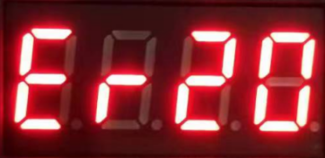 | Overvoltage alarm (It will not automatically return to normal.) | Check if the power supply is normal;  Check if the speeding and overloading are serious;
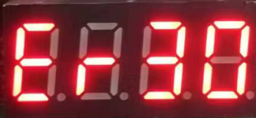 | Undervoltage alarmIt will not automatically return to normal.) | Check if the power supply is normal;

Warranty and after-sales service

7.1 Warranty

7.1.1 Free Warranty Status
Our company solemnly promises that all products purchased from us will be provided with one year of free repair service if they are damaged due to their own defects during use. The round-trip shipping costs will be shared equally by both parties.

7.1.2 Cases not covered by warranty
- The driver was damaged due to incorrect wiring by the customer.
- Exceeding the rated operating voltage can damage the driver.
- Connecting a DC-powered drive to an AC power source can damage the driver.
- The driver was damaged because the customer's site environment was extremely harsh, such as humid, extremely cold, or extremely hot, and the customer did not inform the company in advance.
- The customer disassembled the drive casing without authorization, or there were signs that the serial number had been torn off.
- The casing was visibly damaged or impacted 15 days after the customer confirmed receipt, resulting in damage to the driver.
- Unavoidable natural disasters, such as fires, earthquakes, tsunamis, typhoons, etc.;
In the above situations, our company will charge a certain repair cost fee after assessing the interests of all parties. In all other situations, repairs will be provided free of charge indefinitely.

7.2 Exchange

7.2.1 Product replacement due to malfunction
For any malfunctions in the new product itself, our company offers a three-month free replacement service.
Once our technical support staff confirms the problem is with the product itself, please send the product back to our company to avoid time and postage losses during the round trip. Customers must first send the faulty product back via express delivery or logistics. Upon receiving the product, our company will send a replacement to the customer as soon as possible.
Notice:All our products undergo rigorous testing and aging before leaving the warehouse, so malfunctions of new products are extremely rare. Please read the instruction manual carefully or consult our technical support personnel before operation, or have our technical support personnel remotely assist customers in operation.
- Please note the following points when exchanging goods:
- Please ensure the packaging is intact when returning the item to avoid damage during shipping;
- When exchanging goods, please ensure that all accessories are complete;
- Each driver should be individually packaged in its original outer box to avoid secondary damage to the product during transportation;
- If the drive is returned and confirmed to be not a product malfunction but rather due to customer negligence in operation, resulting in the customer mistakenly believing the drive to be faulty, our company will not bear the shipping costs (customer negligence includes: incorrect wiring leading to drive damage, faulty wiring leading to the mistaken belief that the drive is damaged, operational errors causing the drive to malfunction, etc.).

7.2.2 Replacement for non-product malfunctions
If a customer is dissatisfied with the appearance or function of the received product and wishes to replace it with a superior driver, they can apply for an exchange within one week of receiving the product. After verification, the product will be returned to the company. The company will replace the product with another one, provided the returned product is undamaged, all accessories are complete, and the packaging is in good condition. If there is a price difference in the replacement product, the customer will be responsible for the difference.
Note: Replaced products will no longer be eligible for non-product failure exchange services. All round-trip shipping costs and other expenses incurred for non-product failure exchange services will be borne by the customer!

7.3 Returns
Our company offers a 7-day return policy for products with quality issues. If you discover any quality problems with the product within 7 days of receiving it (based on the actual date of receipt by the customer), please contact our sales representative or technical support personnel in a timely manner. After our technical support personnel confirm that the product has quality issues, the customer should send the original complete product, its inner and outer packaging, accessories, and delivery note back to our company via express delivery or logistics.
If, after our company has inspected and confirmed that there are no errors, the customer still insists on returning the goods, the customer shall bear all round-trip shipping costs and all other expenses incurred as a result.
- Please note the following points when returning goods:
(1) Please contact the relevant department of our company before proceeding with the refund process;
(2) The product must be brand new and in its original packaging. Please send it back to our company by express delivery or logistics.
(3) We will not accept complaints about product damage, missing accessories, or other issues caused by the customer.

7.4 After-sales service
If you require after-sales service support while using this product, please contact our company immediately.
Nationwide toll-free service hotline: 0755-23206995;
Website: http://www.grmot.com//
Technical support hotline: 18576758897 (Mr. Xie), 17666115681 (Mr. Tuo);
Service hours: Monday to Friday, 8:30-17:30 (excluding national statutory holidays).

Version Revision History
Version number | illustrate | Modify deadline | Prepared by/Reviewed by
V1.0.0 | Initial version; | June 27, 2024 | TCJ, JQ/XH
V1.0.1 | - Chapter 4.5 has been optimized;  - Change the indicator lights and alarm indicators in Chapter Six; | July 29, 2024 | TCJ/XH
V1.0.2 | - The Chinese description of the drive model has been changed, and the torque percentage has been modified to a torque rating value.  - The driver power supply voltage related parts have been changed to only support DC power supply;  - In section 4.5.3, the table on page P001 details the addition of 60 parameters for the motor.  - Illustrations of the modifications to Chapters 3.1 and 4.1;  - Chapter 5 updates the power supply description; | October 30, 2024 | TCJ, JQ/XH
V1.0.3 | - Section 4.2 adds a decimal point function to the digital tube display;  - Section 4.5.3 adds acceleration and deceleration settings; | October 7, 2025 | HY/TCJ

